

Raymond S Kellis High School
Cougar Varsity Golf Program
2021 Season
Welcome Potential Cougar Golfer,

We are looking forward to meeting you and are extremely excited for the upcoming 2021 season. We hope you have been practicing and are ready to go, we are excited to work with you to build your skills and we want to get to know all golfers that have an interest. Therefore, no matter what your skill level is at the time you read this, beginner, novice, to advanced, you are welcome to join the Cougar Golf Team and give it a shot, pun intended. This program prides itself on the fact that everyone is here to learn the “greatest game in the world”, have fun and most importantly…use the game of golf as an engine to teach us valuable lessons about life. We do this by offering formative experiences and opportunities to learn and grow as individuals who are brought together to be a part of something bigger than ourselves.
We have created a very positive environment for all our golfers, and plan on continuing this tradition, so please bring your best attitude; it will be imperative if you would like to be a team member. Positive attitudes and willingness to learn will be looked at heavily when picking our varsity golfers. Please read the following items carefully and make sure you follow all instructions. We will have our organizational meeting on Thursday, August 5^{th,} after school in room 1-215 from 2:30-3:00pm.

NEED TO KNOW INFO BEFORE JOINING THE TEAM:

Home Course:
Sun City Country Club
9433 N 107th Ave, Sun City, AZ 85351
Clubhouse Phone Number – (623) 933-1353

Golf Season Requirements
Length of Season: August – October 2021
Practice Days: Monday-Thursday 2:45-5:00pm
Athletes will need to be picked up from Kellis High School student lot (north) each evening.

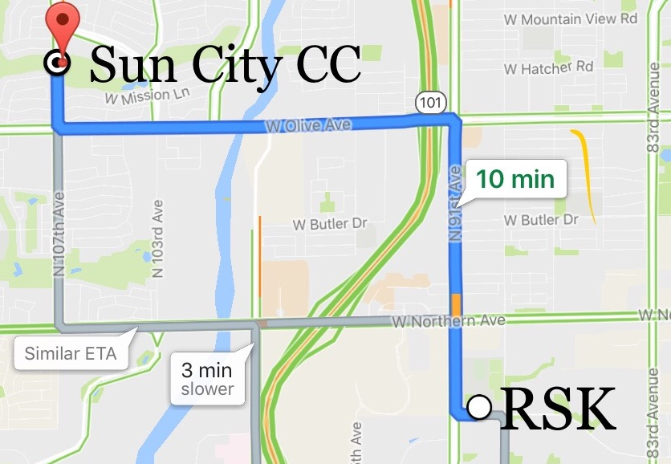

NEED TO BRING ITEMS TO 1ST DAY OF TRYOUTS:
- Register My Athlete information completed and submitted to the Attendance Secretary Mrs. Fox.
- Proper Dress Attire – See Dress Code below
- Water Bottle
- Hat and Sunscreen
- Golf Clubs/Bag – if you have them, if not we have sets of clubs and a bag for each player
- Mandatory meeting will be held on the 1st day of school. First day of practice will then be held Monday August 9th.
2. The way we present ourselves is very important in the game of golf and in life. To play the part, we must look the part. The following dress code will be consistently enforced.
DRESS CODE –
- Ladies - Shorts or a golf skirt/skort
- Collared shirt (No T-shirts)
- No denim or jeans of any kind
- No gym shorts.
- Tennis Shoes or Soft spikes only (No metal spikes)
- Hat/Visor

The Following Items are NOT Permitted:
- Flip flops or sandals
- Cut off shorts
- Gym Shorts/Sweatpants

Parents should pick up athletes within 15 minutes of returning to the school. The athlete will be directed to call for pickup when leaving the golf course each day. This should give families ample time for a prompt pickup.

Let me emphasize again that we are looking for the best all-around student-athletes. This
includes attitudes and schoolwork. Your behavior must be outstanding at all times if you are
going to represent Raymond S Kellis High School. We are building the tradition of not only a
great golf program, while also forming the best young women in the state.

We are looking forward to seeing you on the course!

Straight Ballin’

See you soon,
Coach Swindig – eswindig@pusd11.net – Erin Swindig – Golf Coach

Cbourland@pusd11.net – Carly Bourland – Athletic Director

